**Name:** Abhay Mathur **Sapid:** 60017210016 **Batch:** A1

**Experiment No. 2**

**Aim:** Image Transformations

**Objective:** Develop a program to perform different Image Transformations

**Theory:**

Image Transformation involves the transformation of image data to retrieve information from the image or preprocess the image for further usage

OpenCV (Open Source Computer Vision Library) is an open-source computer vision and machine learning software library. OpenCV was built to provide a common infrastructure for computer vision applications and to accelerate the use of machine perception in commercial products.  By using it, one can process images and videos to identify objects, faces, or even the handwriting of a human. When it is integrated with various libraries, such as [NumPy](https://www.geeksforgeeks.org/python-numpy/), [Python](https://www.geeksforgeeks.org/python-programming-language/) is capable of processing the [OpenCV](https://www.geeksforgeeks.org/opencv-overview/) array structure for analysis.

**Problem Definition**

* Image Translation
* Reflection
* Rotation
* Scaling
* Cropping
* Shearing in x-axis
* Shearing in y-axis

**Observations:**

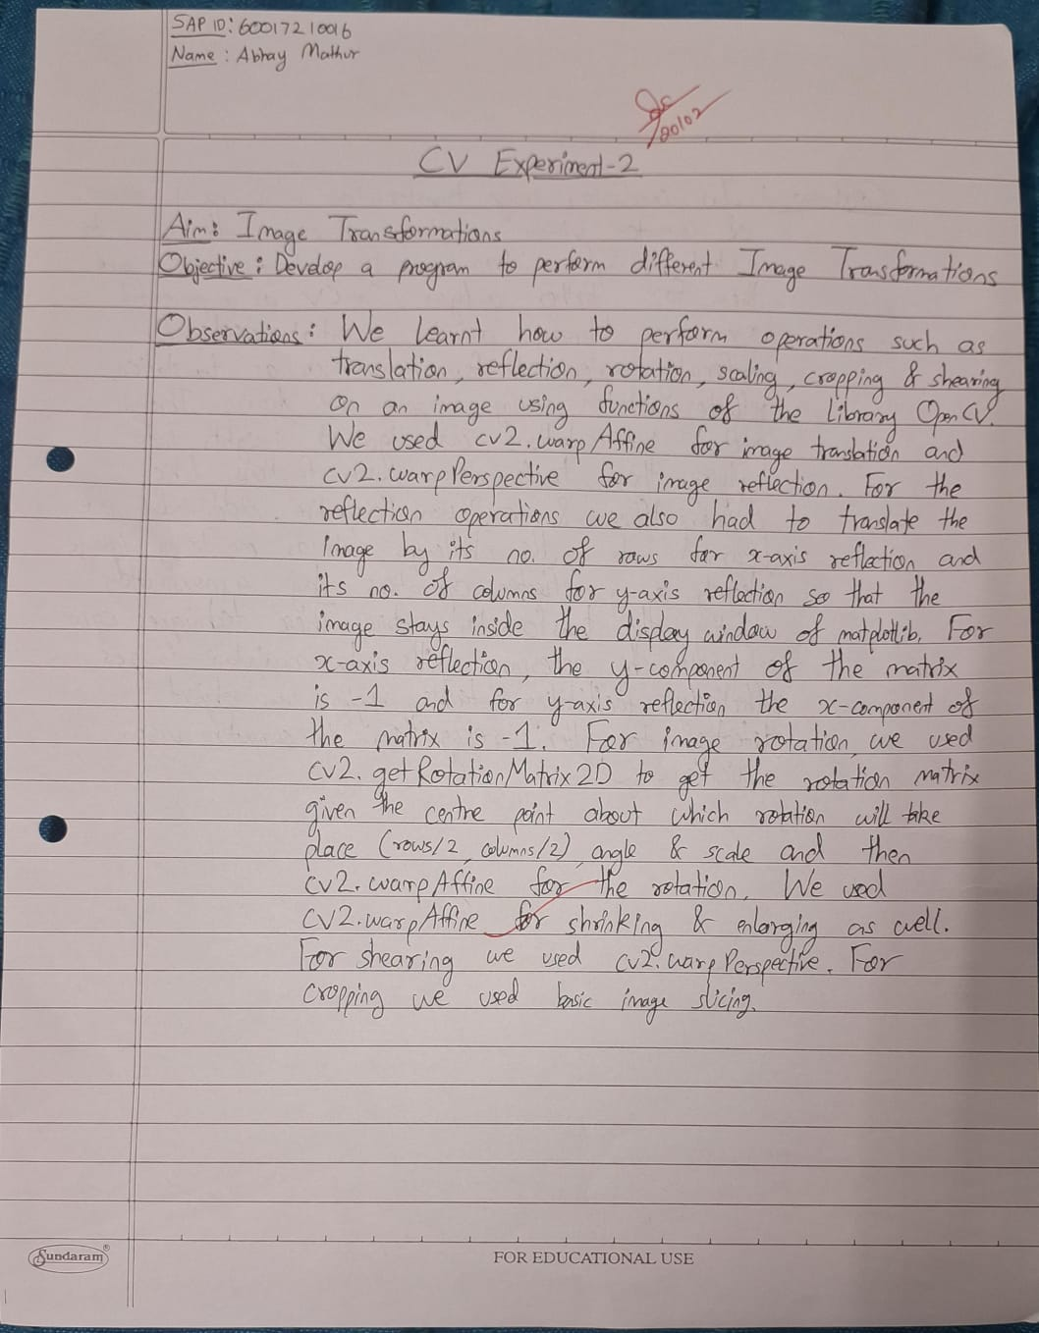

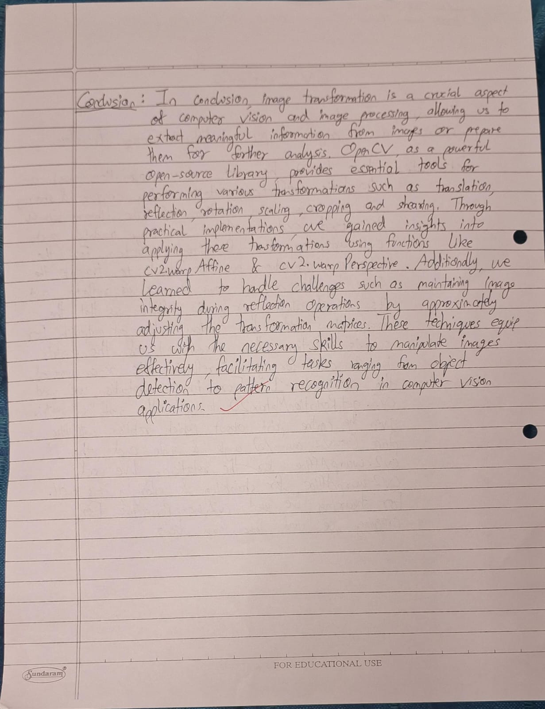

**Conclusion:**

In conclusion, image transformation is a crucial aspect of computer vision and image processing, allowing us to extract meaningful information from images or prepare them for further analysis. OpenCV, as a powerful open-source library, provides essential tools for performing various transformations such as translation, reflection, rotation, scaling, cropping and shearing. Through practical implementations, we gained insights into applying these transformations using functions like cv2.warpAffine and cv2.warpPerspective. Additionally, we learned to handle challenges such as maintaining image integrity during reflection operations by appropriately adjusting the transformation matrices. These techniques equip us with the necessary skills to manipulate images effectively, facilitating tasks ranging from object detection to pattern recognition in computer vision applications.

|  |  |
| --- | --- |
|  |  |